ABC Workshop xx.xx.2020: Name of the course:
Lecturers:
(You can remove the ABC-cards once you have built the storyboard)
Topic | Content | Learning types |  |  |  |  | Evaluation
Orientation  Objectives:  E.g.  Student knows how to proceed in the course, knows the rules, feels like part of the study group, can relate his/her former knowledge to the course topics | E.g.  - Course introduction  - Description of the course structure and elements  - Introduction to the teacher and peer students  - Formation of the teams for team work | 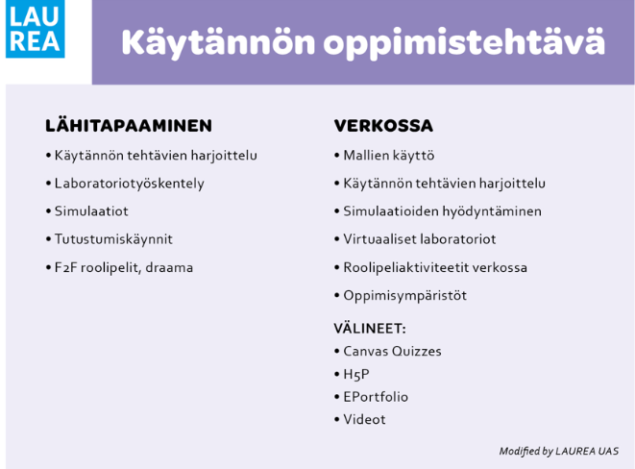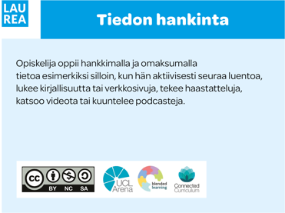 | You can place an ABC card here by dragging or copying it | 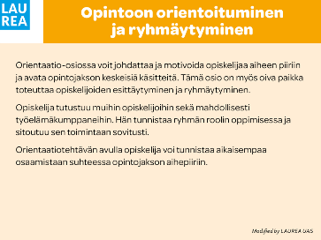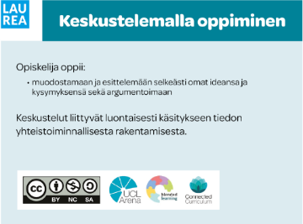 | 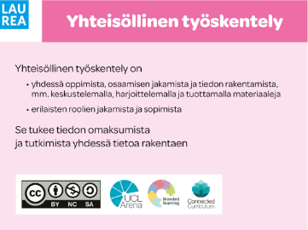 | 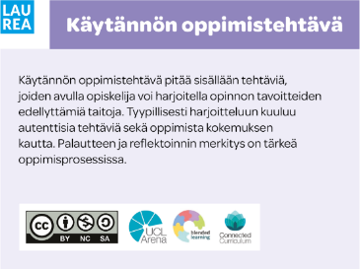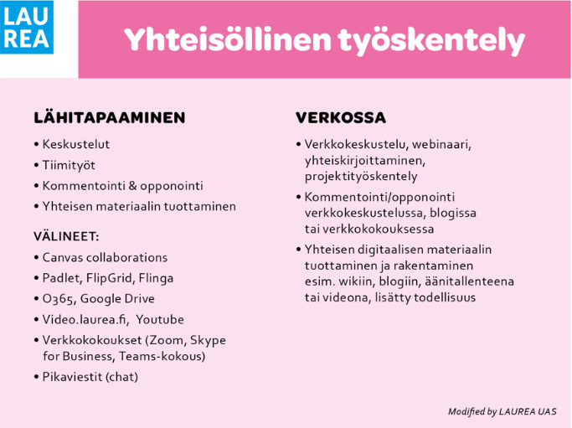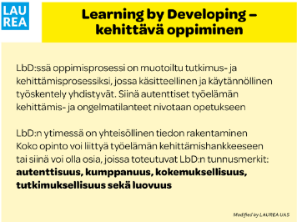 | E.g. - Introduce yourself in the forum: accepted / rejected - Orientation video and progress of studies picture: The student marks as done
 |  | Notes | Notes | Notes | Notes | Notes

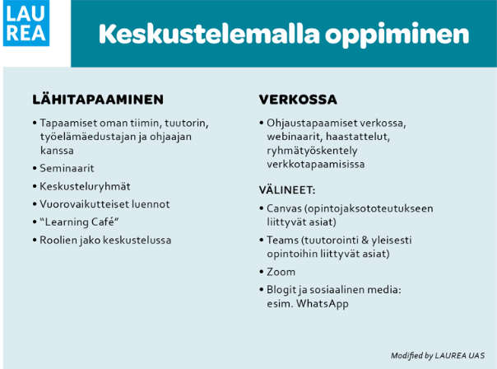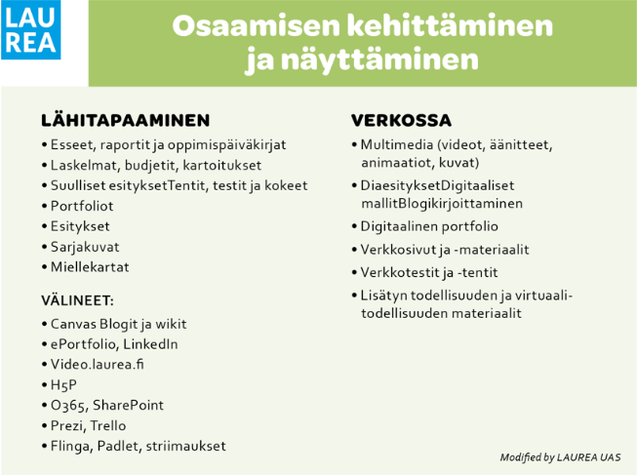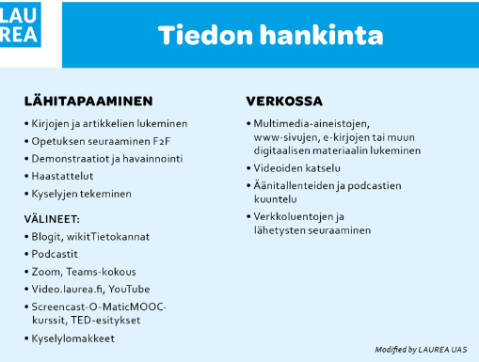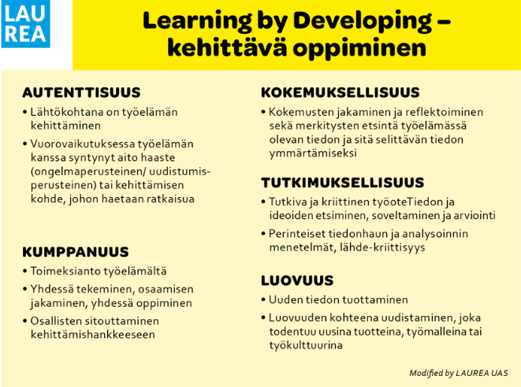
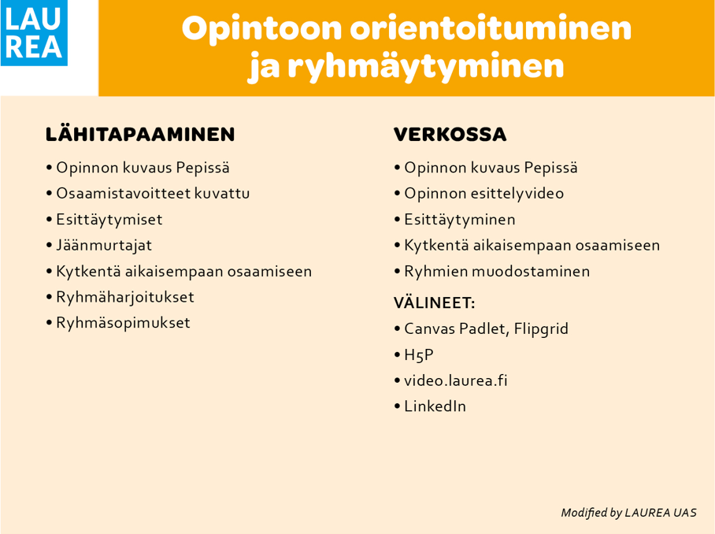

Topic 1 | Content | Learning types |  |  |  |  | Evaluation
Title:  Objectives: |  | You can place an ABC card here by dragging or copying it

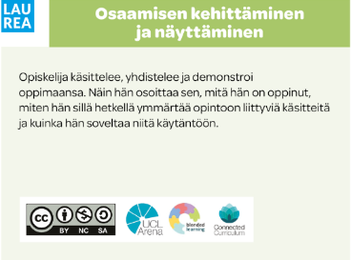

Topic 2 | Content | Learning types |  |  |  |  | Evaluation
Title:  Objectives: |  | You can place an ABC card here by dragging or copying it
 |  | Notes | Notes | Notes | Notes | Notes

Topic 3 | Content | Learning types |  |  |  |  | Evaluation
Title:  Objectives: |  | You can place an ABC card here by dragging or copying it
 |  | Notes | Notes | Notes | Notes | Notes

Topic 4 | Content | Learning types |  |  |  |  | Evaluation
Title:  Objectives: |  | You can place an ABC card here by dragging or copying it
 |  | Notes | Notes | Notes | Notes | Notes

Topic 5 | Content | Learning types |  |  |  |  | Evaluation
Title:  Objectives: |  | You can place an ABC card here by dragging or copying it
 |  | Notes | Notes | Notes | Notes | Notes

Next steps:
What to be done? | Who does and who is responsible? | DL

